**Inspirations**

1. 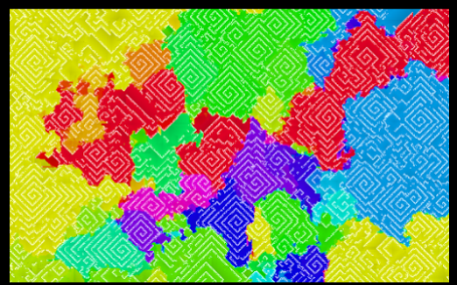Colourful life by Lucas Crane

I found this inspiring as it is mostly random what you see but based off the user inputs with the mouse. I think this breathes a bit more life into what the viewer experiences as they see themselves as partially creating what they are seeing. I would like my project be use a lot of user interaction with the mouse to allow for unique experiences for each person.

<http://jaxry.github.io/colorful-life/>

1. 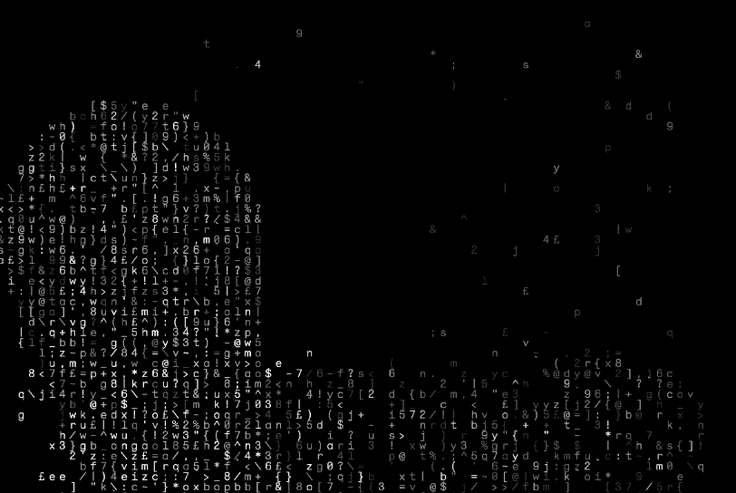ASCII Trail by Neil Carpenter

This appealed to me because of its use of text and has a very strong programming/computing theme to it. I think that combining that style with creative coding works very well and the sort of person interested in generative art could likely enjoy that aesthetic. I also like how this one gives the user a more personal experience by using the mouse as the creator of the text characters.

<http://codedoodl.es/_/neilcarpenter/ascii-trail>

1. 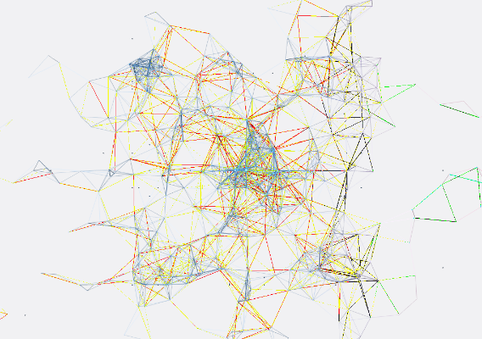Nodes by Taylor Baldwin

This inspired me because of how much detail you can see at once which causes the viewer to be able to stare into it and find it fascinating. The use of random colours slowly changing and overlapping each other constantly leaves there more to be seen because of its complexity. I would like my project to be similar in the way it will stay interesting to look at by giving it some form of complexity.

<http://codedoodl.es/_/rolyatmax/nodes>

**Development Process**

While making my generative art piece I started by having lines randomly appear on the screen but the beginning of all the lines were in the centre so that it seemed the lines were all bursting from that point. I tried tying this point to the mouse but I found that it was never interesting enough to stare at it for more than 10 seconds. Even when the mouse moved the inner point of all the lines it didn’t have enough variation. I think this was because using only lines in this way made it very linear and difficult to make much more interesting so the way to solve that would be to use a shape with another dimension.

Then I tried using rectangles instead of lines and thought made it much more interesting to look at but I still wanted to push it further. I then made it so that according to where the mouse is it decides on the dimensions of the rectangles. This led to a much more interesting viewing experience. I stepped it up again by using this code 4 times but having each one do it on a different part of the screen, top left, top right etc. Each quadrant has different random colours to differentiate them and I think this made it fascinating enough to look at.

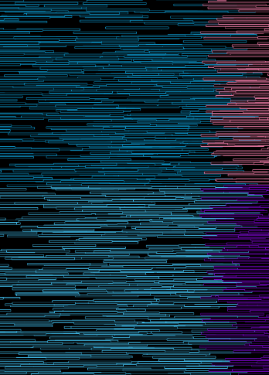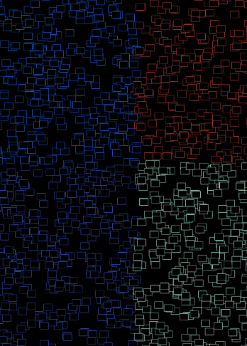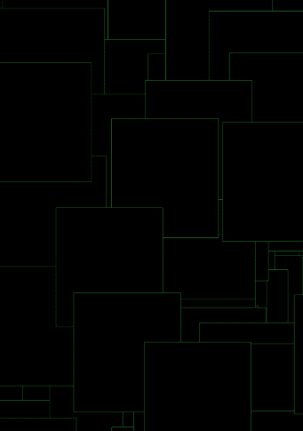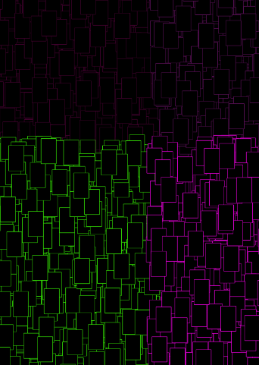One problem I have with my code is that when the mouse is in the top left corner of the screen the point in between the 4 quadrants moves away from the curser, while this doesn’t ruin the experience I would like to be able to fix this in the future. I would also like to be able to find ways to add to it without overloading what is viewable.

<https://github.com/DouglasKellett/Creative-Coding>